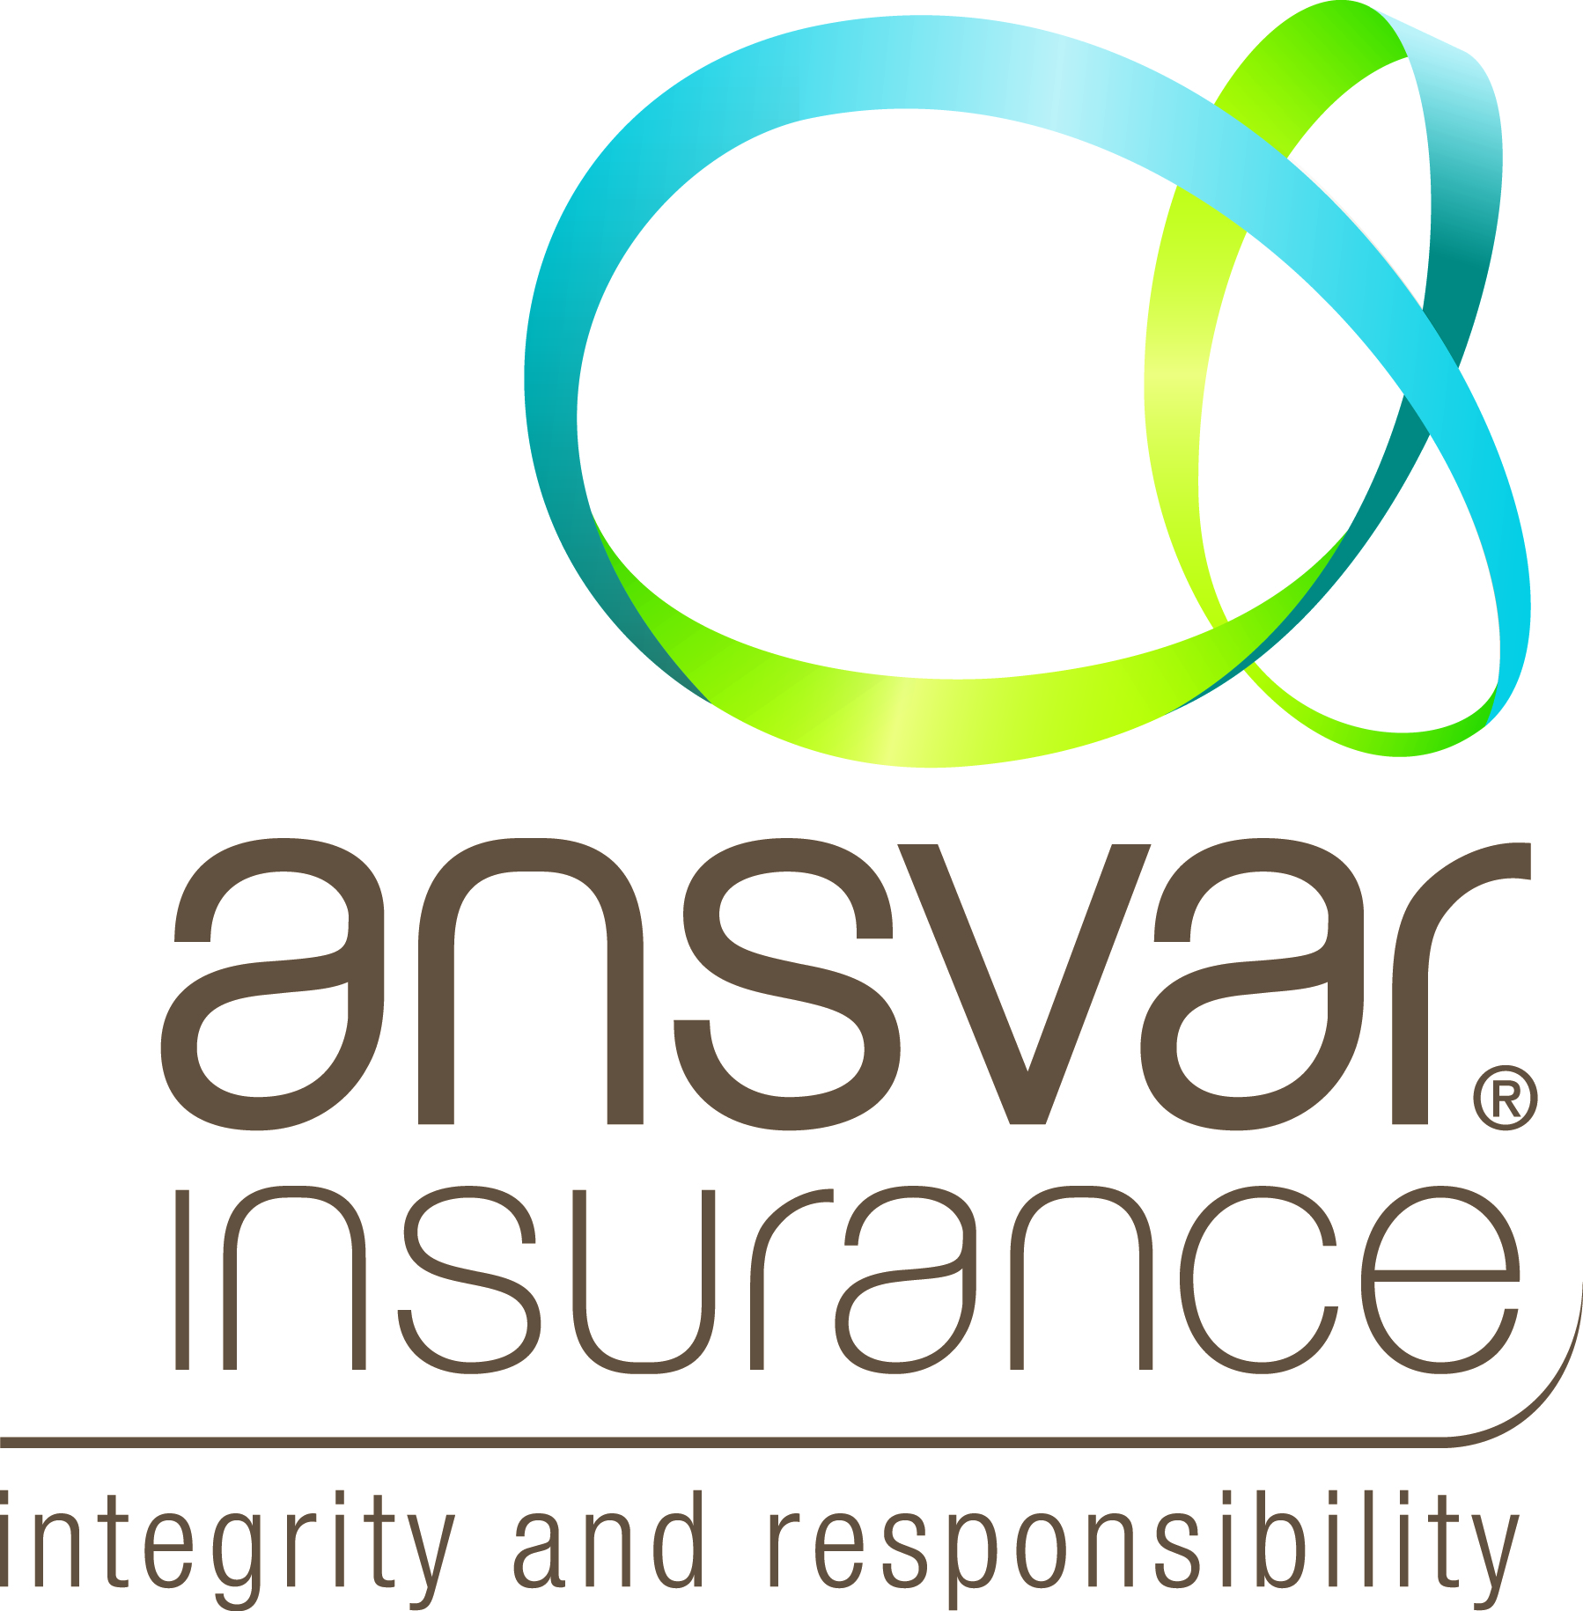
Certificate of Currency – Public Liability
This is to certify that this Ansvar Insurance Limited policy of insurance is current as at the date of issue of this Certificate of Currency, subject to the terms and conditions of the policy indemnifying the Insured as follows:

Policy Number: 609374

Name of Insured: WA Gould League Inc

Type of Policy: Public & Products Liability
$20,000,000 any one occurrence

Description of Risk: Legal liability to pay compensation in respect of:
- Personal Injury
- Property Damage
- Advertising Liability

Business Description: Not for profit organization providing community education on the importance of looking after the environment through environmental science programs and the significance of Lake Herdsman to its Noongar custodians through Indigenous programs.

Geographical Limit: Anywhere in the World except USA/Canada

Period of Insurance: From 4.00pm 31/03/2022 to 4.00pm 31/03/2023

Sean Keown
State Manager - WA

Signed for and on behalf of Ansvar Insurance Limited
Date: 20/05/2022
1300 650 540
ansvar.com.au

GPO Box 1655
Melbourne VIC 3001

Ansvar House
Level 5, 1 Southbank Boulevard
SOUTHBANK VIC 3006

